**Object Oriented Programming Lab 01**

|  |  |
| --- | --- |
| **Course**: Object Oriented Programming (CL1004) | **Semester**: Spring 2025 |
| **Instructor**: Shafique Rehman |  |
| Note:   * Maintain discipline during the lab. * Listen and follow the instructions as they are given. * Just raise hand if you have any problem. * Completing all tasks of each lab is compulsory. * Get your lab checked at the end of the session. |  |

**Introduction to C++**

**Skeleton of C++ Program**

A C++ program is structured in a specific and particular manner. In C++, a program is divided into the following three sections:

1. Standard Libraries Section
2. Main Function Section
3. Function Body Section

For example, let’s look at the implementation of the Hello World program:

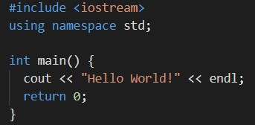

**Standard Libraries Section**



* #include is a specific preprocessor command that effectively copies and pastes the entire text of the file, specified between the angle brackets, into the source code.
* The file <iostream>, which is a standard file that should come with the C++ compiler, is short for input-output streams. This command contains code for displaying and getting an input from the user.
* namespace is a prefix that is applied to all the names in a certain set. iostream file defines two names used in this program - cout and endl.

**Main Function Section**



* The starting point of all C++ programs is the main function.
* This function is called by the operating system when your program is executed by the computer.
* {Signifies the start of a block of code, and} signifies the end.

**Input/Output in C++ Program**

* C++ is very similar to the C Language.
* For the input/output stream we use <iostream> library (in C it was <stdio>).
* For taking input and out we cout and cin (in C it was printf and scanf).
* cout uses insertion ( << ) operator.
* cin uses extraction ( >> ) operator.

**Sample C++ Code**

#include <iostream>

using namespace std;

int main()

{

int var = 0;

cout << "Enter an Integer value: ";

cin >>var;

}

**Variables & Data Types in C++**

While writing a program in any language, you need to use various variables to store various information. Variables are nothing but reserved memory locations to store values. This means that when you create a variable you reserve some space in memory.

You may like to store information of various data types like character, wide character, integer, floating point, double floating point, Boolean etc. Based on the data type of a variable, the operating system allocates memory and decides what can be stored in the reserved memory.

**Primitive Built-in Types**

C++ offers the programmer a rich assortment of built-in as well as user defined data types.

Following table lists down seven basic C++ data types:

|  |  |
| --- | --- |
| **Type** | **Keyword** |
| Boolean | bool |
| Character | char |
| Integer | int |
| Floating point | float |
| Double floating point | double |
| Valueless | void |
| Wide character | wchar_t |

Several of the basic types can be modified using one or more of these type modifiers:

* signed
* unsigned
* short
* long

The following table shows the variable type, how much memory it takes to store the value in memory, and what is maximum and minimum value which can be stored in such type of variables:

|  |  |  |
| --- | --- | --- |
| **Type** | **Typical Bit Width** | **Typical Range** |
| char | 1byte | -127 to 127 or 0 to 255 |
| unsigned char | 1byte | 0 to 255 |
| signed char | 1byte | -127 to 127 |
| int | 4bytes | -2147483648 to 2147483647 |
| unsigned int | 4bytes | 0 to 4294967295 |
| signed int | 4bytes | -2147483648 to 2147483647 |
| short int | 2bytes | -32768 to 32767 |
| unsigned short int | 2bytes | 0 to 65,535 |
| signed short int | 2bytes | -32768 to 32767 |
| long int | 8bytes | -9223372036854775808 to 9223372036854775807 |
| signed long int | 8bytes | same as long int |
| unsigned long int | 8bytes | 0 to 18446744073709551615 |
| long long int | 8bytes | -(2^63) to (2^63)-1 |
| unsigned long long int | 8bytes | 0 to 18,446,744,073,709,551,615 |
| float | 4bytes |  |
| double | 8bytes |  |
| long double | 12bytes |  |
| wchar_t | 2 or 4 bytes | 1 wide character |

The size of variables might be different from those shown in the above table, depending on the compiler and the computer you are using.

Following is the example, which will produce correct size of various data types on your computer:

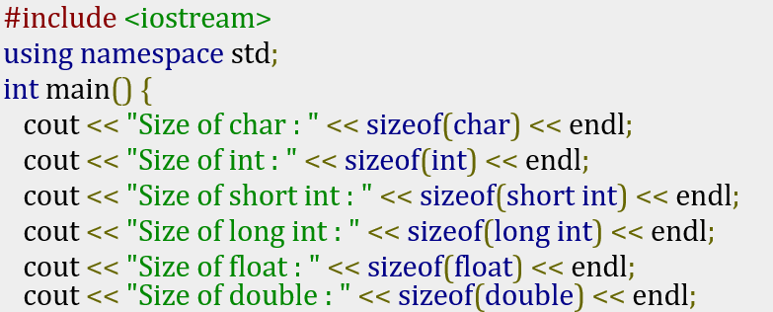

This example uses **endl**, which inserts a new-line character after every line and **<<** operator is being used to pass multiple values out to the screen. We are also using **sizeof()** function to get size of various data types.

When the above code is compiled and executed, it produces the following result which can vary from machine to machine:

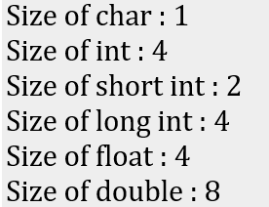

Following is another example:

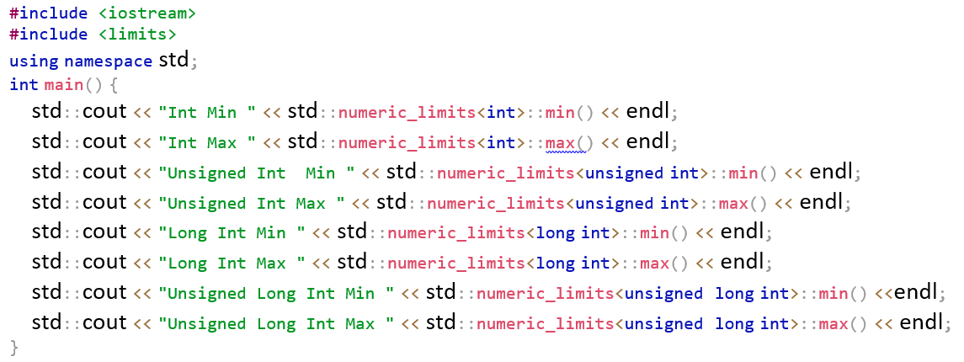

**typedef declaration**

You can create a new name for an existing type using typedef. Following is the simple syntax to define a new type using typedef:

**typedef type newname**;

For example, the following tells the compiler that feet is another name for int:

**typedef int feet;**

Now, the following declaration is perfectly legal and creates an integer variable called distance:

**feet distance;**

**Functions in C++**

A function is a block of code that performs a specific task. Suppose we need to create a program to create a circle and color it. We can create two functions to solve this problem:

1. a function to draw the circle.
2. a function to color the circle.

Dividing a complex problem into smaller chunks makes our program easy to understand and reusable. There are two types of function:

1. Standard Library Functions: Predefined in C++
2. User-defined Function: Created by user

**User-Defined Functions**

C++ allows the programmer to define their own function. A user-defined function groups code to perform a specific task and that group of code is given a name (identifier).

When the function is invoked from any part of the program, it all executes the codes defined in the body of the function.

The syntax to declare a function is:

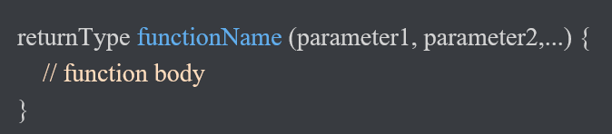

Here's an example of a function declaration:

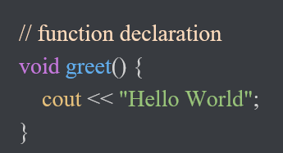

Here, the name of the function is **greet()** the return type of the function is **void** the empty parentheses mean it doesn't have any parameters the function body is written inside **{}.**

**Calling Functions**

In the above program, we have declared a function named greet(). To use the greet() function, we need to call it. Here's how we can call the above greet() function:

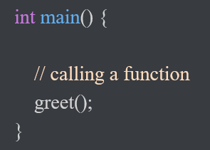

**Functions Parameters**

As mentioned above, a function can be declared with parameters (arguments). A parameter is a value that is passed when declaring a function.

For example, let us consider the function below:

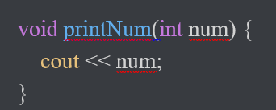

Here, the **int** variable **num** is the function parameter. We pass a value to the function parameter while calling the function:

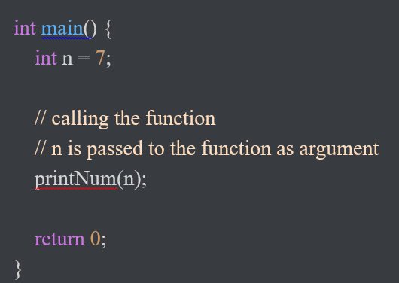

**Example: Function with Parameters**

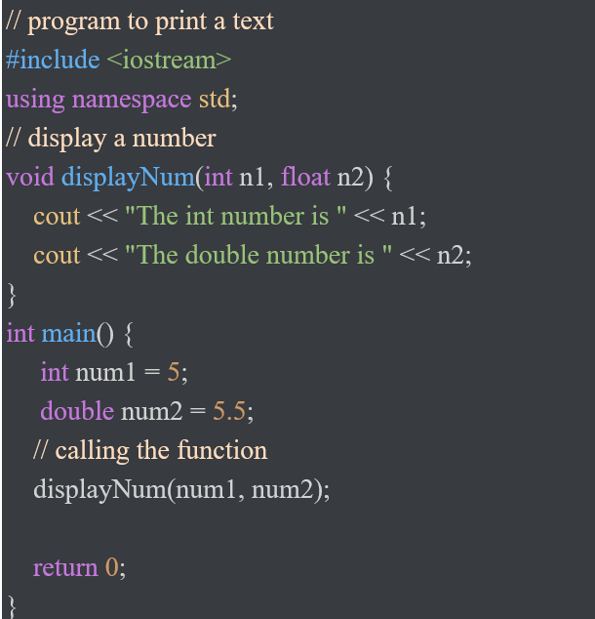

In the above program, we have used a function that has one int parameter and one double parameter. We then pass **num1** and **num2** as arguments. These values are stored by the function parameters **n1** and **n2** respectively.

**Return Statement**

In the above programs, we have used void in the function declaration. For example:

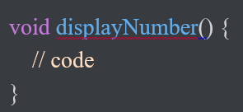

This means the function is not returning any value. It's also possible to return a value from a function. For this, we need to specify the returnType of the function during function declaration.

Then, the return statement can be used to return a value from a function. For example:

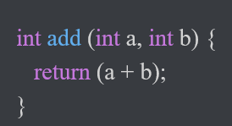

Here, we have the data type int instead of void. This means that the function returns an int value.

The code return (a + b); returns the sum of the two parameters as the function value. The return statement denotes that the function has ended. Any code after return inside the function is not executed.

**Example: Add Two Numbers**

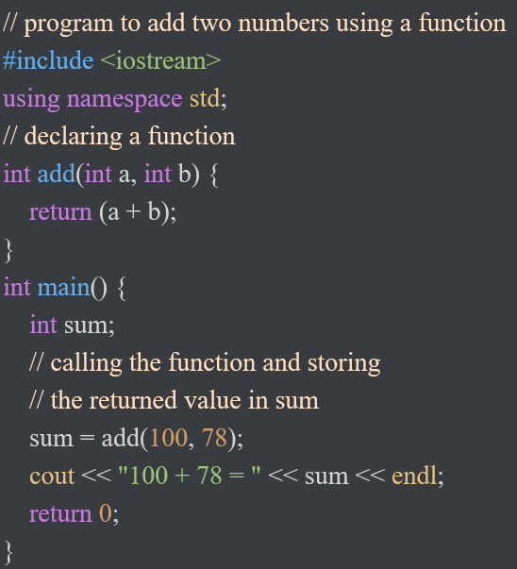

In the above program, the add() function is used to find the sum of two numbers. We pass two int literals 100 and 78 while calling the function. We store the returned value of the function in the variable sum, and then we print it.

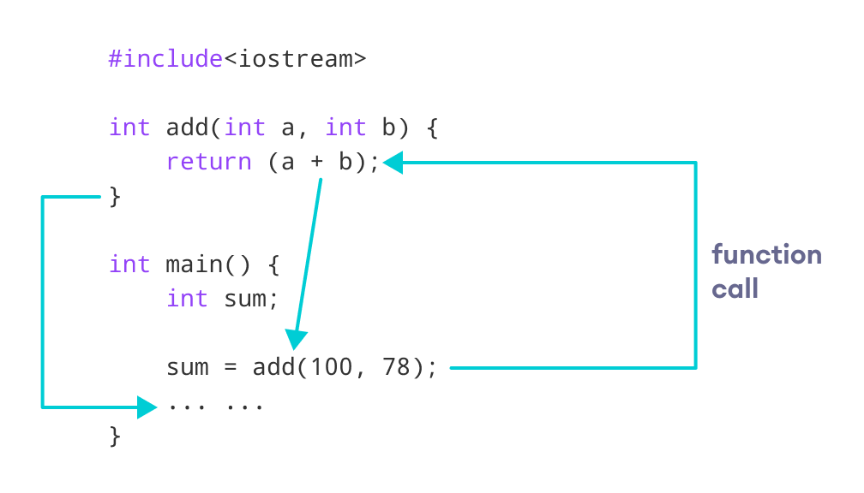

**Function Prototype**

In C++, the code of function declaration should be before the function call. However, if we want to define a function after the function call, we need to use the function prototype. For example:

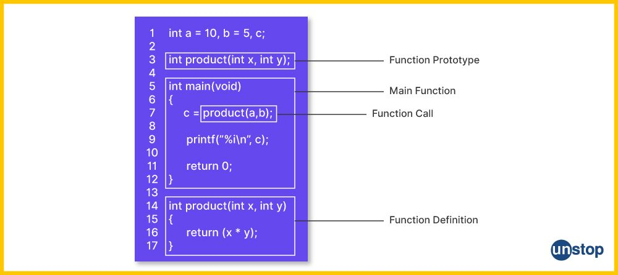

This provides the compiler with information about the function name and its parameters. That's why we can use the code to call a function before the function has been defined. The syntax of a function prototype is:

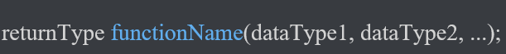

**Example: C++ Function Prototype**

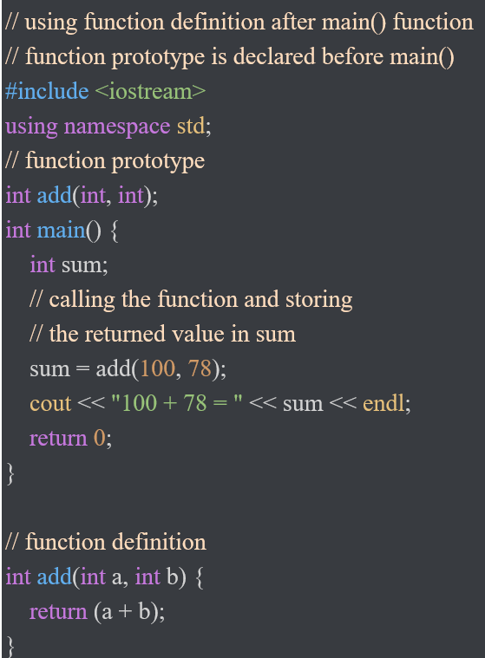

Functions make the code reusable. We can declare them once and use them multiple times. Functions make the program easier as each small task is divided into a function. Functions increase readability.

**C++ Library Functions**

Library functions are the built-in functions in C++ programming. Programmers can use library functions by invoking the functions directly; they don't need to write the functions themselves.

Some common library functions in C++ are sqrt(), abs(), isdigit(), etc.

In order to use library functions, we usually need to include the header file in which these library functions are defined. For instance, in order to use mathematical functions such as sqrt() and abs(), we need to include the header file cmath.

**Example: C++ Function Prototype**

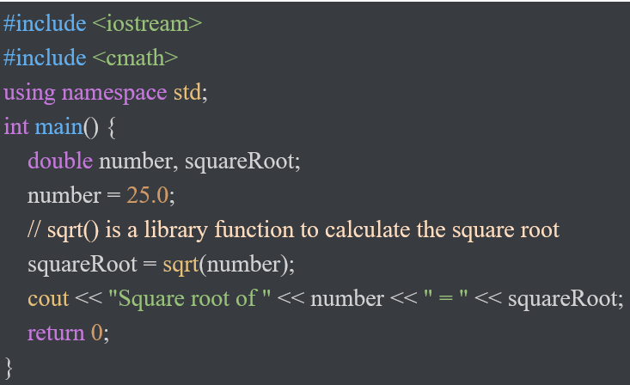

**Arrays in C++**

An Array is a collection of fixed number of elements of same data type.

**1-D Array**

1-D Array is a form of array in which elements are arranged in a form of List. To declare a 1D array you need to specify the data type, name and array size.

**dataType arrayName [ arraySize ];**

Following is an example of declaration of a 1D array:

**int numArray[5];**

To access array elements, you use the array name along with the index in subscript operator **“[ ]”.**

**numArray[0], numArray[1], numArray[2], numArray[3], numArray[4]**

**Example: Code for 1-D Array**

Program to read five numbers, find their sum, and print the numbers in reverse order.

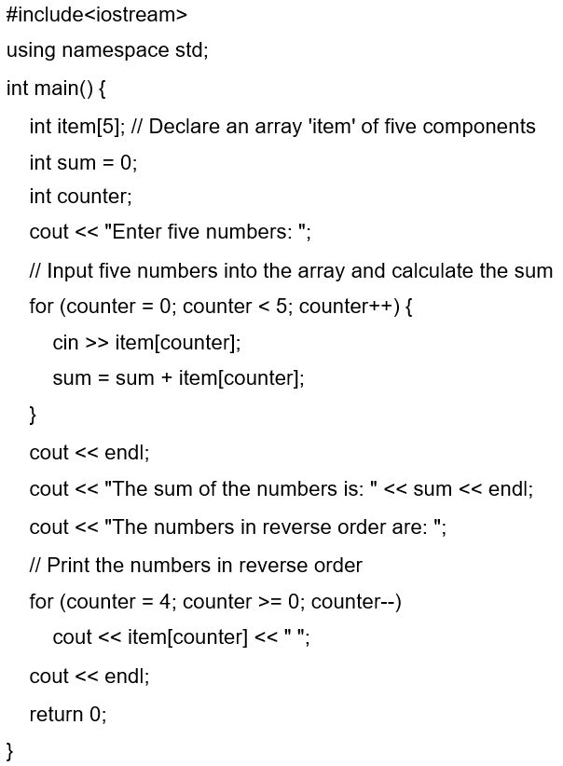

**2-D Array**

2-D Array is a collection of fixed collection of elements arranged in rows and columns. To declare a 2D array you need to specify the data type, name and no. of rows and columns.

**dataType arrayName [ rowSize ][ columnSize ];**

Following is an example of declaration of a 2D array:

**int numArray[5][5];**

To access array element you use the array name along with the row Index and column Index in subscript operator **“[ ][ ]”.**

**numArray[0][0], numArray[1][1], numArray[2][2], numArray[3][3], numArray[4][4];**

**Example: Code for 2-D Array**

Program to read a 2D array of size 3x3 find the sum for each row, print the sum line by line.

